Axis in Solid Geometry
# Source: AI Source: Provided by: [Data Path: Persons Table -> ID Column: 1, Name_En Column: Motasem Essam] -> From: [ChatGPT] on [7/25/2026]
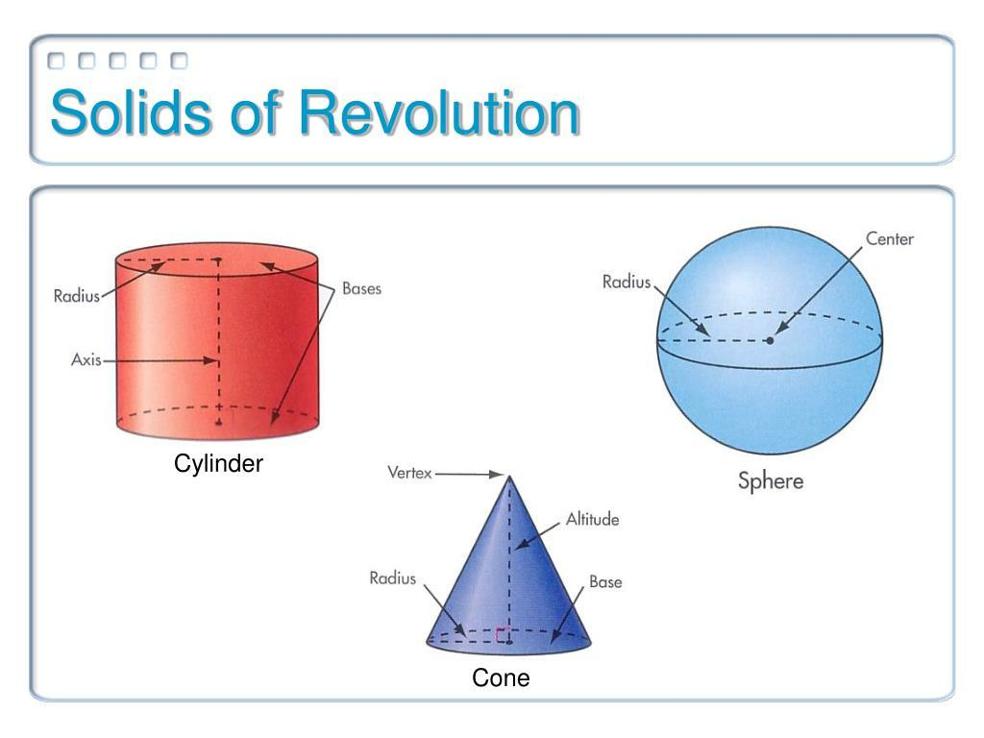
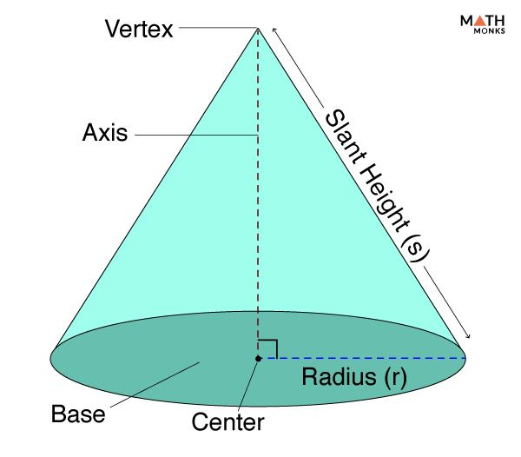
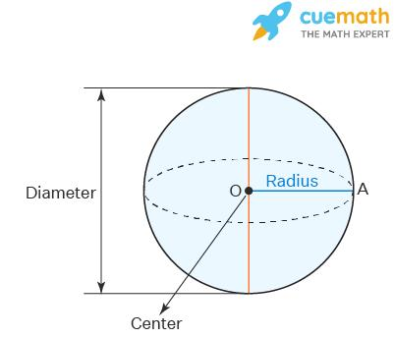

Definition
# Source: AI Source: Provided by: [Data Path: Persons Table -> ID Column: 1, Name_En Column: Motasem Essam] -> From: [ChatGPT] on [7/25/2026]
In solid geometry, an axis is a straight line used as a reference to describe the position, orientation, symmetry, or rotation of a three-dimensional geometric object.
Depending on the solid and context, an axis may pass through the center of a solid, connect an apex to the center of a base, or serve as a line about which a two-dimensional shape rotates to generate a solid.

Simple Definition
# Source: AI Source: Provided by: [Data Path: Persons Table -> ID Column: 1, Name_En Column: Motasem Essam] -> From: [ChatGPT] on [7/25/2026]
An axis is an imaginary straight line that helps describe a solid's direction, symmetry, or rotation.

Types of Axes in Solid Geometry
# Source: AI Source: Provided by: [Data Path: Persons Table -> ID Column: 1, Name_En Column: Motasem Essam] -> From: [ChatGPT] on [7/25/2026]
Axes can be classified according to their geometric role.
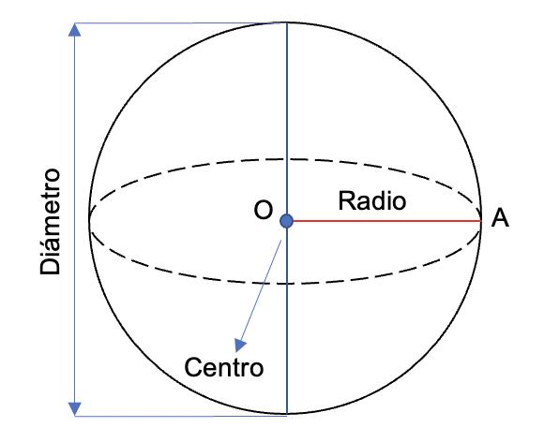

1. Central Axis
# Source: AI Source: Provided by: [Data Path: Persons Table -> ID Column: 1, Name_En Column: Motasem Essam] -> From: [ChatGPT] on [7/25/2026]
A line passing through the center of a solid. For a sphere, any line through its center can serve as a central axis.
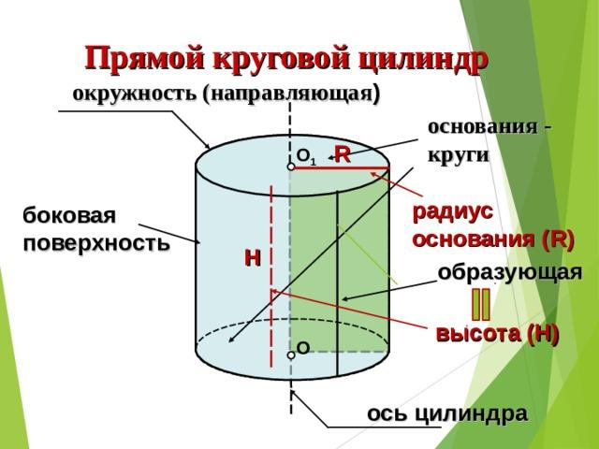

2. Axis of a Cylinder
# Source: AI Source: Provided by: [Data Path: Persons Table -> ID Column: 1, Name_En Column: Motasem Essam] -> From: [ChatGPT] on [7/25/2026]
The line joining the centers of the two circular bases. In a right circular cylinder, this axis is perpendicular to both bases.

3. Axis of a Cone
# Source: AI Source: Provided by: [Data Path: Persons Table -> ID Column: 1, Name_En Column: Motasem Essam] -> From: [ChatGPT] on [7/25/2026]
The line joining the apex to the center of the base. In a right circular cone, it is perpendicular to the base.
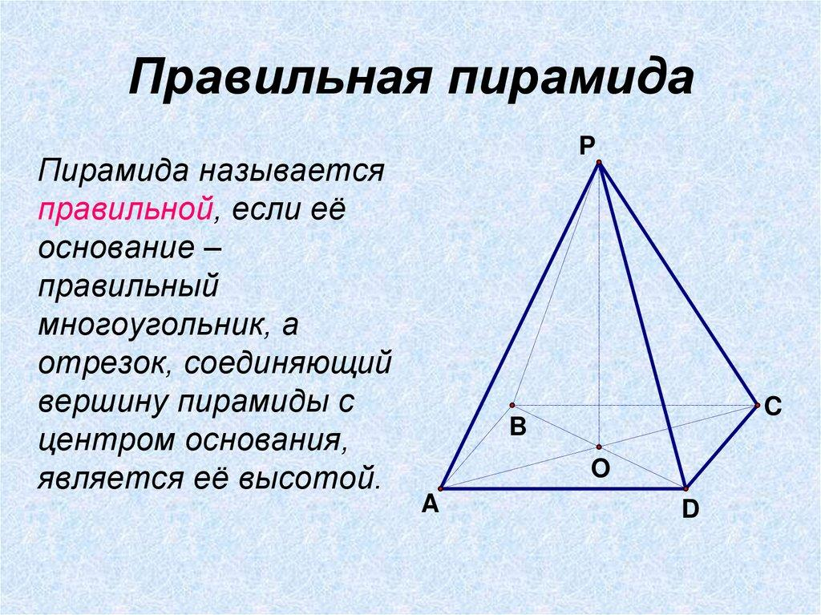

4. Axis of a Pyramid
# Source: AI Source: Provided by: [Data Path: Persons Table -> ID Column: 1, Name_En Column: Motasem Essam] -> From: [ChatGPT] on [7/25/2026]
In a regular pyramid, the axis is the line joining the apex to the center of the regular base, perpendicular to the base plane.
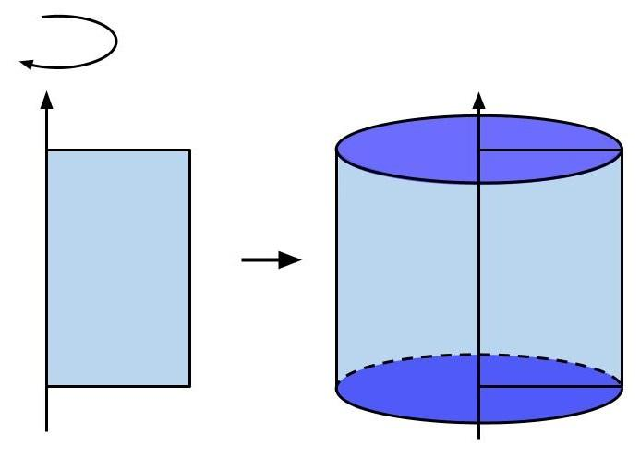

5. Axis of Rotation
# Source: AI Source: Provided by: [Data Path: Persons Table -> ID Column: 1, Name_En Column: Motasem Essam] -> From: [ChatGPT] on [7/25/2026]
A fixed line around which a plane figure or solid rotates. For example, rotating a rectangle around one of its sides generates a cylinder.
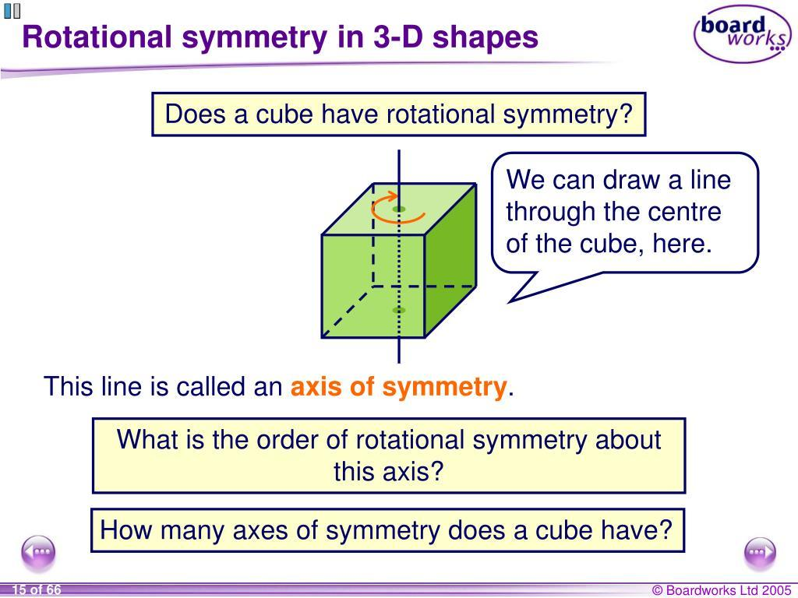

6. Axis of Symmetry
# Source: AI Source: Provided by: [Data Path: Persons Table -> ID Column: 1, Name_En Column: Motasem Essam] -> From: [ChatGPT] on [7/25/2026]
A line associated with a solid's symmetry. For rotational symmetry, rotating the solid around the axis through certain angles leaves its appearance unchanged.
Note: These categories describe different roles, not mutually exclusive types. For example, the central axis of a right circular cylinder is also an axis of rotational symmetry and an axis of rotation.

Main Parts and Symbols
# Source: AI Source: Provided by: [Data Path: Persons Table -> ID Column: 1, Name_En Column: Motasem Essam] -> From: [ChatGPT] on [7/25/2026]
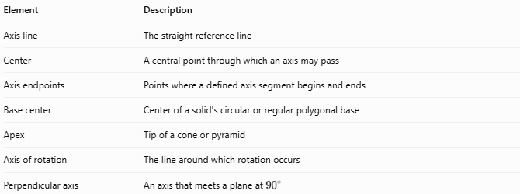
Element | Description
Axis line | The straight reference line
Center | A central point through which an axis may pass
Axis endpoints | Points where a defined axis segment begins and ends
Base center | Center of a solid's circular or regular polygonal base
Apex | Tip of a cone or pyramid
Axis of rotation | The line around which rotation occurs
Perpendicular axis | An axis that meets a plane at ${90}^{∘}$
An axis may be represented by a line such as $AB$, or by a named line such as $OO'$. A geometric axis can extend indefinitely; an axis segment may instead be bounded by specified points.

Mathematical Properties

A. Axis of a Right Circular Cylinder
# Source: AI Source: Provided by: [Data Path: Persons Table -> ID Column: 1, Name_En Column: Motasem Essam] -> From: [ChatGPT] on [7/25/2026]
For a cylinder of height $h$, the axis connects the centers of its bases.
If the axis is perpendicular to the bases, the perpendicular distance between the bases equals the cylinder's height:
$$\boxed{\text{Axis length}=h}$$

B. Axis of a Right Circular Cone
# Source: AI Source: Provided by: [Data Path: Persons Table -> ID Column: 1, Name_En Column: Motasem Essam] -> From: [ChatGPT] on [7/25/2026]
For a right circular cone with height $h$, the axis joins the apex to the center of the circular base.
$$\boxed{\text{Axis length}=h}$$
The slant height $l$, base radius $r$, and axis length $h$ satisfy:
$$\boxed{l^{2}=h^{2}+r^{2}}$$

C. Axis of a Sphere
# Source: AI Source: Provided by: [Data Path: Persons Table -> ID Column: 1, Name_En Column: Motasem Essam] -> From: [ChatGPT] on [7/25/2026]
For a sphere of radius $R$, any line through the center can be selected as an axis. If the axis is represented by a diameter, its length is
$$\boxed{d=2R}$$
Unlike a cylinder or cone, a sphere has no single unique central axis: every line through its center is geometrically equivalent.

D. Axis of Rotation
# Source: AI Source: Provided by: [Data Path: Persons Table -> ID Column: 1, Name_En Column: Motasem Essam] -> From: [ChatGPT] on [7/25/2026]
When a plane figure rotates around an axis, each point not on the axis traces a circular path centered on that axis. The resulting three-dimensional shape is called a solid of revolution.
Examples include:
- A rectangle rotated about one side produces a cylinder.
- A right triangle rotated about one leg produces a right circular cone.
- A semicircle rotated about its diameter produces a sphere.

Worked Examples
# Source: AI Source: Provided by: [Data Path: Persons Table -> ID Column: 1, Name_En Column: Motasem Essam] -> From: [ChatGPT] on [7/25/2026]
Example 1: Axis Length of a Cylinder
A right circular cylinder has a height of $12\text{ cm}$. Find the length of its central axis between the base centers.
For a right circular cylinder, the axis length equals the height.
$$\boxed{L=12\text{ cm}}$$
Example 2: Finding the Cone's Axis Length
A right circular cone has a slant height of $13\text{ cm}$ and a base radius of $5\text{ cm}$. Find its axis length.
Using the Pythagorean theorem:
$$l^{2}=h^{2}+r^{2}$$
$$h=\sqrt{l^{2}-r^{2}}$$
$$h=\sqrt{{13}^{2}-5^{2}}=\sqrt{169-25}$$
$$\boxed{h=12\text{ cm}}$$
Example 3: Finding a Sphere's Diameter Along an Axis
A sphere has radius $R=7\text{ cm}$. Find the length of a diameter chosen as its axis.
$$d=2R=2\left(7\right)$$
$$\boxed{d=14\text{ cm}}$$

Comparison with Related Geometric Elements
# Source: AI Source: Provided by: [Data Path: Persons Table -> ID Column: 1, Name_En Column: Motasem Essam] -> From: [ChatGPT] on [7/25/2026]
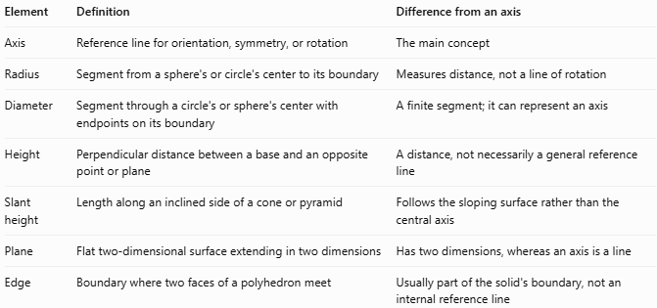
Element | Definition | Difference from an axis
Axis | Reference line for orientation, symmetry, or rotation | The main concept
Radius | Segment from a sphere's or circle's center to its boundary | Measures distance, not a line of rotation
Diameter | Segment through a circle's or sphere's center with endpoints on its boundary | A finite segment; it can represent an axis
Height | Perpendicular distance between a base and an opposite point or plane | A distance, not necessarily a general reference line
Slant height | Length along an inclined side of a cone or pyramid | Follows the sloping surface rather than the central axis
Plane | Flat two-dimensional surface extending in two dimensions | Has two dimensions, whereas an axis is a line
Edge | Boundary where two faces of a polyhedron meet | Usually part of the solid's boundary, not an internal reference line

Applications
# Source: AI Source: Provided by: [Data Path: Persons Table -> ID Column: 1, Name_En Column: Motasem Essam] -> From: [ChatGPT] on [7/25/2026]
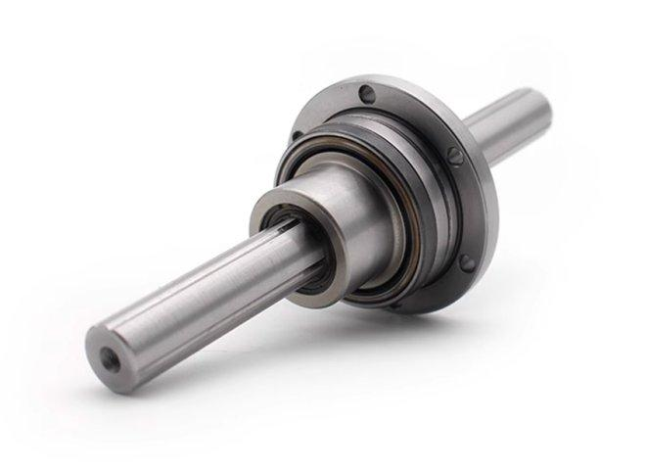
Engineering and Mechanics
Axes describe shafts, rotating components, and the orientation of mechanical parts.
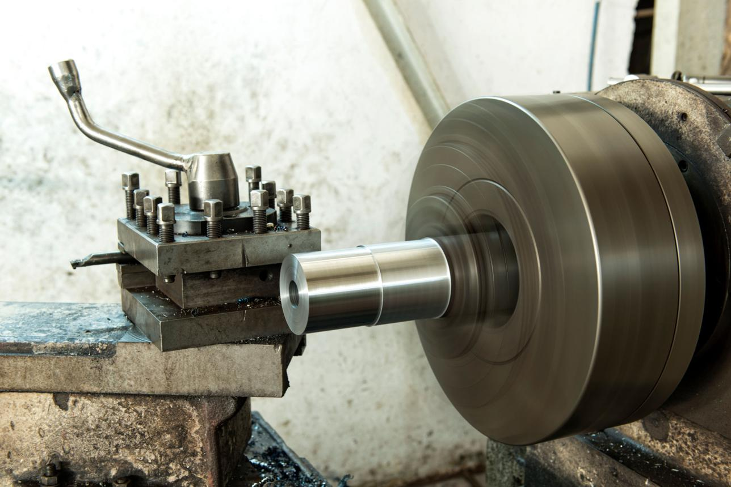
Manufacturing
A rotation axis helps describe how cylindrical and other rotationally symmetric parts are produced.
Mathematics and Geometry
Axes help define solids of revolution, identify symmetry, and describe the positions of geometric elements.

Key Points
# Source: AI Source: Provided by: [Data Path: Persons Table -> ID Column: 1, Name_En Column: Motasem Essam] -> From: [ChatGPT] on [7/25/2026]
- An axis is a reference line used to describe a solid's orientation, symmetry, or rotation.
- A right circular cylinder's axis joins the centers of its circular bases.
- A right circular cone's axis joins its apex to the center of its base.
- Any line through a sphere's center can serve as an axis.
- An axis of rotation generates circular paths for points away from the axis.
- An axis of symmetry describes rotational symmetry when applicable.
- Not every solid has a unique axis, and not every axis must be perpendicular to a base.

Conclusion
# Source: AI Source: Provided by: [Data Path: Persons Table -> ID Column: 1, Name_En Column: Motasem Essam] -> From: [ChatGPT] on [7/25/2026]
An axis in solid geometry is a reference line that helps describe the structure, orientation, symmetry, or rotation of a three-dimensional solid. Its precise meaning depends on the solid: it may connect base centers, join an apex to a base center, pass through a sphere's center, or serve as a line of rotation.

